9.36-8th Main question

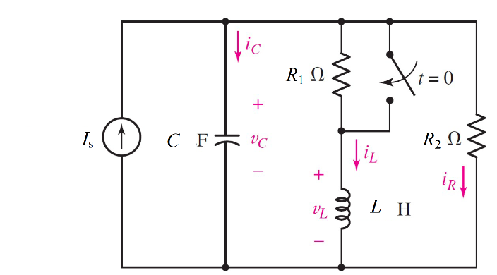

Given Is = 3 *u(-t) A*, r1= 2 Ω, r2= 50 Ω, c = 2.5 *µ*F, l= 20 mH

Find

Variables

Random variables

#l < 4*r*r*c Parallel, c < 4*r*r/l Series

is = {1:5};

r1 = {1:5};

r2 = {40:50};

c = {2e-6:3e-6:0.5e-6};

l = {0.02:0.04;0.01};

Global variables

#is = 3; r1 = 2; r2 = 50; c = 2.5e-6;

l = 20e-3; time = 0.001;

# t = 0-

il0 = (r2/(r1+r2))*is;

vc0 = il0*r1;

ir2 = is-il0;

# t = 0+

rth = r2;

alpha = 1/(2*rth*c);

w0 = 1/sqrt(l*c);

wd = sqrt(w0*w0-alpha*alpha);

ic0 = il0-ir2;

A1 = vc0;

A2 = (ic0/c+alpha*A1)/wd;

vct = (A1*cos(wd*time) + A2*sin(wd*time))exp(-alpha*time);

Part (กรอกคำตอบ)

1. *vc*(0-) = vc0 = 5.768 V

2. *iL*(0-) = il0 = 2.884A

3. *α* = alpha = 4000 s^-1

4. *ω*0 = w0 = 4472.136 rad/s

At *t* > 0

5. *vc*(*t*) = (A1*cos(wd*t) + A2*sin(wd*t))exp(-alpha*t)

= (5.76*cos(2000*t) – 588.464*sin(2000*t))exp(-4000*t) V

6. *vc*(time*τ*) = vct = -9.8444 V

9.37-8th Main question

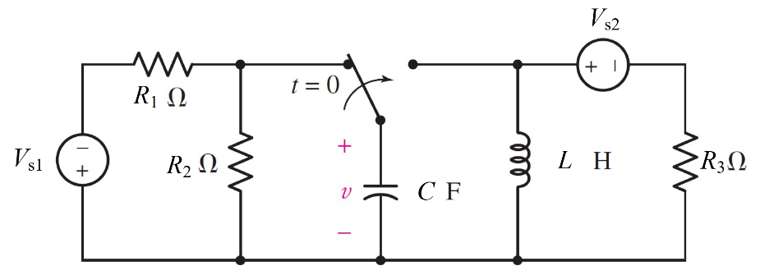

Given vs1 = 2 *V*, vs2 = 5 *u(-t) V*, r1= 5 Ω, r2= 5 Ω, r3= 2 Ω, c = 2 *m*F, l= 20 mH

Find

Variables

Random variables

#l < 4*r*r*c Parallel, c < 4*r*r/l Series

vs1 = {1:5};

vs2 = {1:5};

r1 = {5:10};

r2 = {1:5};

r3 = {1:5};

c = {2e-3:5e-3:1e-3};

l = {0.02:0.04;0.01};

Global variables

#vs1 = 2;vs2=5, r1 = 5; r2 = 5,r3=2; c = 2e-3;

l = 20e-3; time = 1;

# t = 0-

il0 =vs2/r3;

vc0 = -(r2/(r1+r2))*vs1;

# t = 0+

rth = r3;

alpha = 1/(2*rth*c);

w0 = 1/sqrt(l*c);

wd = sqrt(w0*w0-alpha*alpha);

ir3=vc0/r3

ic0 = -il0-ir3;

A1 = vc0;

A2 = (ic0/c+alpha*A1)/wd;

vct = (A1*cos(wd*time) + A2*sin(wd*time))exp(-alpha*time);

Part (กรอกคำตอบ)

1. *vc*(0-) = vc0 = -1 V

2. *iL*(0-) = il0 = 2.5A

3. *α* = alpha = 125 s^-1

4. *ω*0 = w0 = 158.11 rad/s

At *t* > 0

5. *vc*(*t*) = (A1*cos(wd*t) + A2*sin(wd*t))exp(-alpha*t)

= (-1*cos(96.64*t) – 11.62*sin(96.64*t))exp(-125*t) V

6. *vc*(time*τ*) = vct = -2.9022 V

9.39-8th Main question

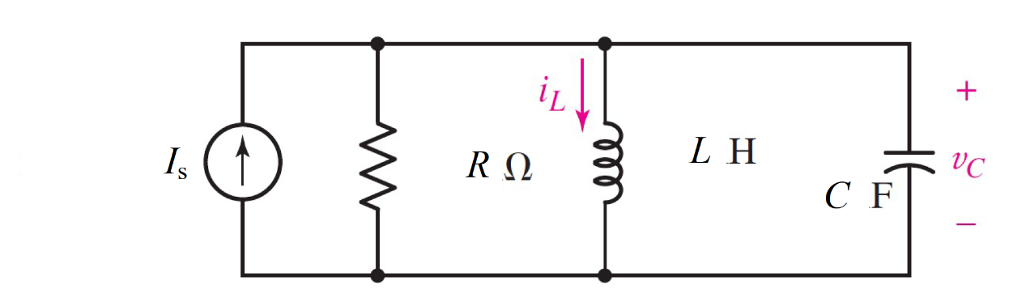

Given Is = 2.5 *u(-t)A*, r= 500 mΩ, c = 250 mF, l= 160 mH Find

Variables

Random variables

#l < 4*r*r*c Parallel, c < 4*r*r/l Series

is = {0.5:3:0.5};

r = {0.5:5;0.5};

l = {0.1:0.2:0.01};

c = {0.1:0.5:0.05};

Global variables

#is = 310 e-3; r = 14; c = 0.36e-3;

l = 1; time = 1;

# t = 0-

il0 = is;

vc0 = 0;

# t = 0+

rth = r;

alpha = 1/(2*rth*c);

w0 = 1/sqrt(l*c);

wd = sqrt(w0*w0-alpha*alpha);

ir3=vc0/r3

vl0=vc0;

A1 = il0;

A2 = (vl0/l+alpha*A1)/wd;

ilt = (A1*cos(wd*time) + A2*sin(wd*time))exp(-alpha*time);

Part (กรอกคำตอบ)

1. *iL*(0-) = il0 = 2.5A

2. *vc*(0-) = vc0 = 0 V

3. *α* = alpha = 4 s^-1

4. *ω*0 = w0 = 5 rad/s

At *t* > 0

5. *iL*(*t*) = (A1*cos(wd*t) + A2*sin(wd*t))exp(-alpha*t)

= (2.5*cos(3*t) + 3.33*sin(3*t))exp(-4*t) V

6. *iL*(time*τ*) = vct = -0.0367 V

9.43-7th Main question

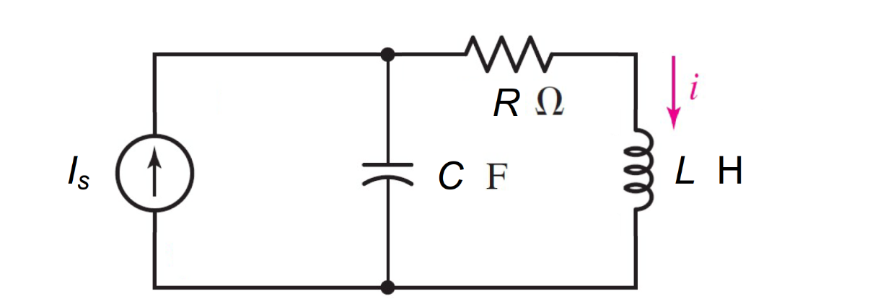

Given Is = 10 *u(-t) A*, r= 2 Ω, c = 0.2 F, l= 0.25 H Find

Variables

Random variables

#l < 4*r*r*c Parallel, c < 4*r*r/l Series

is = {1:10};

r = {1:5:};

l = {0.1:0.5:0.05};

c = {0.1:0.5:0.1};

Global variables

#is = 0.5 ; r = 140; c = 0.5;

l = 12; time = 1;

# t = 0-

il0 = is;

vc0 = 0;

# t = 0+

rth = r;

alpha = rth/(2*l);

w0 = 1/sqrt(l*c);

wd = sqrt(w0*w0-alpha*alpha);

vl0=vc0;

A1 = il0;

A2 = (vl0/l+alpha*A1)/wd;

ilt = (A1*cos(wd*time) + A2*sin(wd*time))exp(-alpha*time);

Part (กรอกคำตอบ)

1. *iL*(0-) = il0 = 10A

2. *vc*(0-) = vc0 = 0 V

3. *α* = alpha = 4 s^-1

4. *ω*0 = w0 = 4.4472 rad/s

At *t* > 0

5. *iL*(*t*) = (A1*cos(wd*t) + A2*sin(wd*t))exp(-alpha*t)

= (10*cos(2*t) + 20*sin(2*t))exp(-4*t) V

6. *iL*(time*τ*) = vct = 0.2569 V